
KERN RIVER VALLEY CHAMBER OF COMMERCE

BUSINESS OR ORGANIZATION

NOMINATION FORM

The Kern River Valley Chamber of Commerce is accepting nominations for its 2024 Business of the Year and Organization of the Year awards. Use this form to submit your nomination(s.)
The deadline to submit nominations is Friday, September 20th, by 12:00pm.
Nominees do not have to be members of the KRV chamber. Entities must have been in operation for a minimum of three years.
Possible attributes to consider in making your nominations:
Businesses

- Provides exemplary customer service
- Has contributed to economic growth
- Has improved the image of the business environment or contributed to beautification
- Supports community groups and organizations
- Exhibits an entrepreneurial spirit

Organizations

- Large Impact. Benefits a large cross section of the Valley, in contrast to benefiting a relatively small number of people.
- Addresses a significant problem
- Provides an important service
- Cultivates leaders
- Builds vocational or other skills in others

Type of Nomination (Choose One) OR
Name of Business or Organization :
Name of person submitting the nomination:
Reasons for Nomination: (attach additional supporting documents if needed)

Business or Organization of the Year Awards Nomination Form (Continued)

If nominee is selected for an award, would you be available to introduce or help present the award on October 9th, noon, at the Chamber’s General Membership Meeting?

Phone Number of Person Making the Nomination:
Email:
Name of Contact Person at the Business of Organization:
Phone Number of the Contact Person:
Email of Contact Person:

THANK YOU FOR YOUR NOMINATION

Selected Organizations will be announced at the October General Membership Meeting.

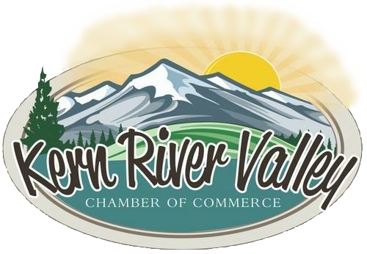

Please contact the Kern River Valley Chamber of Commerce by email at office@kernrivervalley.com or by telephone at (760) 379-5236 if assistance is needed

